|  |  |
| --- | --- |
| Semester | T.E. Semester V – Computer Engineering |
| Subject | Computer Network |
| Subject Professor In-charge | Prof. Amit K. Nerurkar |
| Assisting Teachers | Prof. Amit K. Nerurkar |
| Laboratory | M-313-A |

|  |  |
| --- | --- |
| Student Name | Deep Salunkhe |
| Roll Number | 21102A0014 |
| TE Division | A |

**Title:** **Introduction to Computer Network**

**Explanation:**

**🡺what is Computer Network?**

A computer network is a collection of interconnected computers, devices, and communication.

channels that allow the exchange of data and resources among them. The primary purpose of a

computer network is to enable efficient and reliable communication, sharing of information, and

collaboration between users and devices within the network.

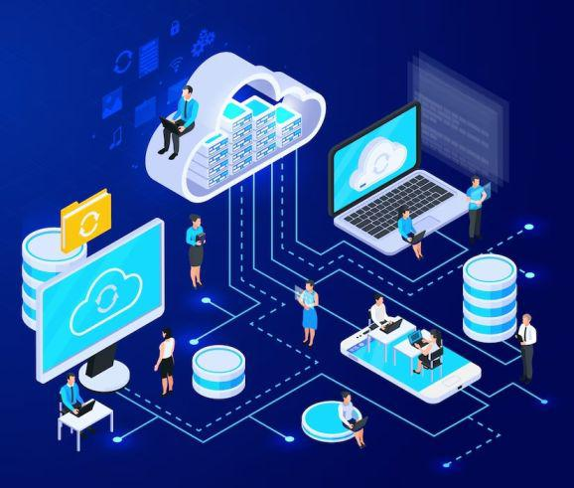

**🡺How computer network got evolved?**

**Early Networking Concepts (1960s)**: In the early days of computing, individual computers

operated in isolation, and there was a growing recognition of the potential benefits of connecting

them. Researchers began exploring concepts like time-sharing, which allowed multiple users to

access a single computer remotely. The development of packet-switching, a method of breaking

data into small packets for transmission across a network, laid the foundation for modern data

communication.

**ARPANET and the Birth of the Internet (1960s-1970s):** The Advanced Research Projects Agency

Network (ARPANET) was a pioneering project funded by the United States Department of

Defense. It went online in 1969 and is considered the precursor to the internet. ARPANET used

packet-switching technology and connected computers at various research institutions, enabling

the exchange of data and resources.

**TCP/IP and Standardization (1970s):** The Transmission Control Protocol (TCP) and Internet

Protocol (IP) were developed in the 1970s, providing a set of rules and standards for data

transmission and communication across networks. TCP/IP became the foundation of the modern

internet and allowed different networks to interconnect, forming a global network of networks.

**Ethernet and Local Area Networks (LANs) (1970s-1980s)**: Ethernet, developed by Robert

Metcalfe at Xerox PARC in the early 1970s, became the dominant technology for connecting

computers within a local area. Ethernet&#39;s popularity led to the creation of LANs, allowing devices

within a limited geographic area to communicate and share resources.

**Commercialization of the Internet (1990s):** The 1990s saw the commercialization of the internet,

leading to its widespread adoption by businesses and the general public. The introduction of web

browsers like Netscape Navigator and Internet Explorer made the internet more user-friendly, and

the World Wide Web (WWW) became a crucial aspect of internet usage, allowing easy access to

information and services.

**Broadband and High-Speed Internet (2000s):** Advancements in telecommunications and

networking technologies led to the widespread adoption of broadband internet, offering high-

speed and always-on connectivity. This allowed for richer multimedia content, online video

streaming, and other bandwidth-intensive applications.

**Wireless Networks and Mobility (2000s):** The proliferation of wireless technologies, such as Wi-Fi,

Bluetooth, and cellular networks, brought about the era of mobile computing. Users could now

access the internet and connect to networks while on the move, leading to the rapid growth of

smartphones, tablets, and other mobile devices.

**Internet of Things (IoT) (2010s):** The concept of the Internet of Things emerged, where everyday

objects and devices are equipped with sensors and connectivity to communicate with each other

and exchange data over the internet. This has led to smart homes, smart cities, and various IoT

applications.

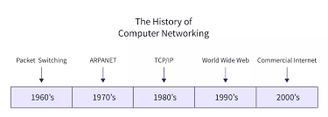

**🡺what are topologies of computer network?**

**Bus Topology:**

In a bus topology, all devices are connected to a single central cable called the &quot;bus.&quot; Each

device on the network receives all the data transmitted on the bus but will only process data

intended for itself. One drawback of the bus topology is that if the main cable (bus) fails, the entire

network may become inoperable.  
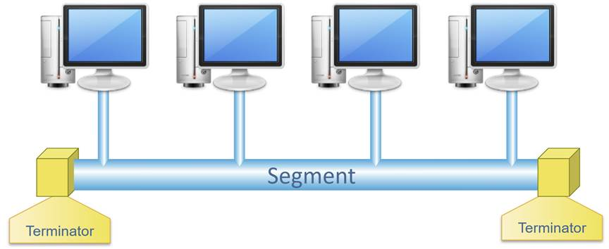

**Star Topology:**

In a star topology, all devices are connected directly to a central hub or switch. The central hub

acts as a connection point for all devices, and data transmissions are relayed through the hub. If

one device or cable fails, it will not affect the rest of the network, as all communication goes

through the central hub.

**Ring Topology:**

In a ring topology, devices are connected in a closed-loop, forming a ring-like structure. Each

device is connected directly to two neighboring devices, and data circulates around the ring until it

reaches its intended destination. Ring topologies can suffer from performance issues if a single

device or connection fails, disrupting the entire network.

**Mesh Topology:**

In a mesh topology, every device is connected to every other device in the network, creating a

fully interconnected system. Mesh networks are highly fault-tolerant, as data can be rerouted

through multiple paths if one link fails. However, this connectivity comes at the cost of increased

complexity and cabling requirements.  
  
**Tree Topology (Hierarchical Topology):**

A tree topology combines characteristics of the bus and star topologies. Devices are arranged in

a hierarchical structure with multiple levels of hubs or switches. The higher-level hubs connect to

lower-level hubs, forming a tree-like structure. Tree topologies allow for scalable Tree topology,

also known as hierarchical topology, is a network structure that combines characteristics of the

bus and star topologies. It forms a tree-like hierarchy with multiple levels of interconnections,

typically with a root node at the top and branches extending downward to lower-level nodes. Tree

topology is often used in large networks, as it allows for efficient organization and easy

expansion.

**key features and characteristics of the tree topology:**

Root Node: At the top of the hierarchy, there is a central node called the root node or the main

hub. The root node acts as the primary connection point for all other nodes in the network. In

some cases, the root node could be a central switch or a powerful network device.

Levels: The tree topology is organized into levels or layers. Each level represents a hierarchical

tier of interconnected nodes. The levels radiate from the root node, with lower-level nodes

branching out from higher-level nodes.

Branches: Each level of the hierarchy has branches that extend downward to lower levels. These

branches represent the connections between nodes. Typically, each node at a higher level has

multiple child nodes at the next lower level.

Parent and Child Nodes: In a tree topology, nodes at a higher level are considered the parent

nodes, and nodes at the next lower level are called child nodes. Each child node is directly

connected to its parent node, and data flows from the parent node to its children.

Data Transmission: Data transmission in a tree topology usually follows a path from the root node

to the specific destination node. The root node broadcasts data to all its child nodes, and each

child node, in turn, broadcasts the data to its children until it reaches the intended destination

node.

Fault Isolation: One of the advantages of the tree topology is its fault isolation capability. If a node

or connection fails in a particular branch, it only affects the nodes in that branch. The rest of the

network remains operational, as the root node and other branches are not affected.

Scalability: Tree topologies are easily scalable. When new devices or nodes need to be added to

the network, they can be connected as child nodes to existing parent nodes. This hierarchical

expansion makes it relatively straightforward to grow the network as needed.

Centralized Control: Since the root node acts as the central point of connection, network

administrators can have better control and management of the network. This centralized control

can streamline network administration tasks and facilitate easier troubleshooting.

Examples of tree topology in practice include organizational networks in large companies,

campus networks connecting multiple buildings in a university, and regional networks linking

branches of a bank or retail chain.network expansion and can handle large networks efficiently.  
  
**Hybrid Topology:**

A hybrid topology is a combination of two or more different topologies. For example, a network

may have a combination of star and bus topologies or a mix of ring and mesh topologies. This

approach allows network designers to customize the network to meet specific requirements and

optimize performance.

Each network topology has its advantages and disadvantages, and the choice of the best

topology depends on factors such as network size, fault tolerance requirements, ease of

installation, scalability, and cost considerations. Network administrators carefully evaluate these

factors to determine the most suitable topology for a particular network implementation.

**🡺Types of Networks**

**Personal Area Network (PAN):**

* Range: Up to 10 meters (approximately 33 feet)
* Description: A PAN is a network used for communication between devices in close proximity to an individual, such as a smartphone connecting to a smartwatch or a wireless mouse connecting to a computer.

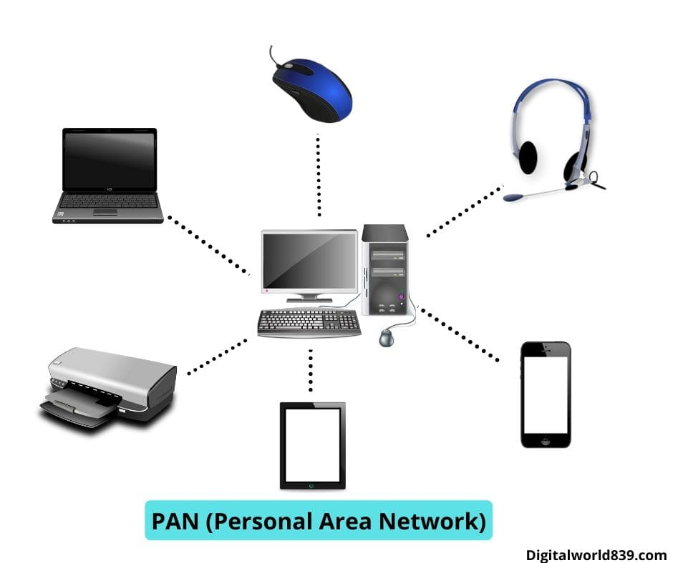

**Local Area Network (LAN):**

* Range: Up to a few Kilometres.
* Description: A LAN is a network that covers a small geographic area, such as a single building, office, home, or campus. It is used for connecting devices within close proximity, allowing them to share resources like files, printers, and internet access. Ethernet and Wi-Fi are common technologies used in LANs

**Campus Area Network (CAN):**

* Typically covers a university campus or large office complex.
* Description: A CAN is a network that connects multiple buildings within a limited geographic area, such as a college campus or a large corporate office.

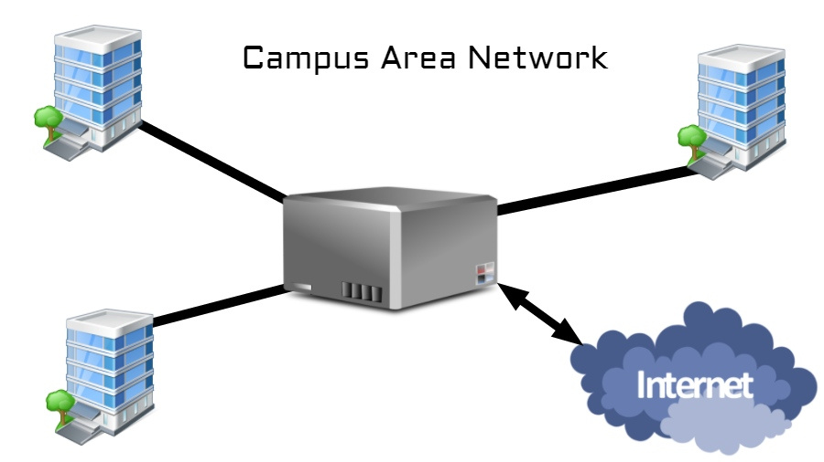

**Metropolitan Area Network (MAN):**

* Range: Spans across a city or metropolitan area.
* Description: A MAN is a network that covers a larger area than a LAN but smaller than a WAN. It connects multiple LANs together within a city or metropolitan region.

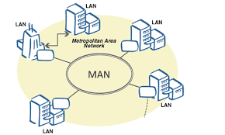

**Wide Area Network (WAN**:

* Range: Can span across cities, countries, or even continents.
* Description: A WAN is a network that covers a large geographical area and connects multiple LANs and MANs together. The Internet is the most well-known example of a WAN, covering the entire globe.

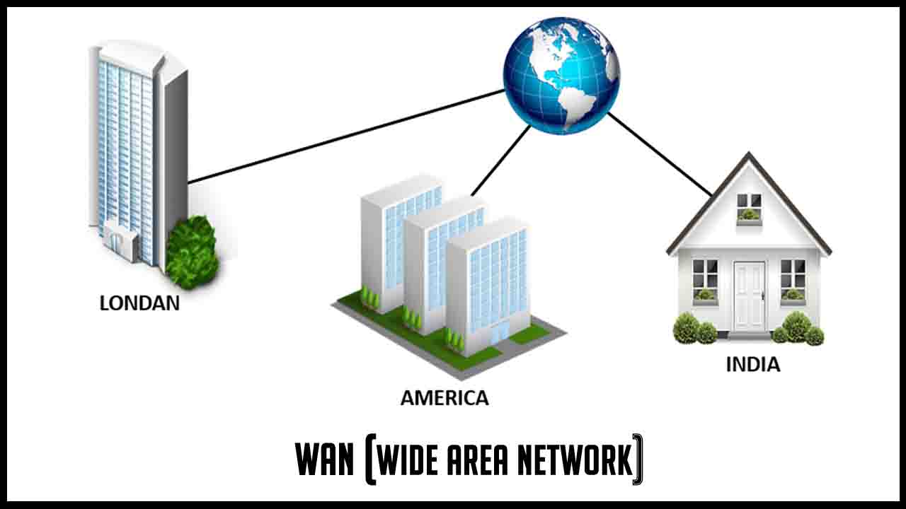

**Conclusion:**

Computer networks are interconnected systems that allow the exchange of data and resources among devices and users. They evolved from early isolated computers to the birth of the internet with ARPANET. TCP/IP standardization enabled global networking, and Ethernet popularized Local Area Networks (LANs). The commercialization of the internet in the 1990s led to widespread adoption, and advancements in technology brought high-speed internet and wireless networks.

Topologies in computer networks define their structure. Bus connects devices to a central cable; Star links devices to a central hub; Ring forms a closed-loop; Mesh interconnects all devices; and Tree is hierarchically arranged Network. Hybrid combines multiple topologies for customized networks.

Network types include PAN for personal devices, LAN for small areas, CAN for campus, MAN for metropolitan regions, and WAN for large geographical areas. The Internet represents a global WAN. The evolution of computer networks has revolutionized communication, collaboration, and access to information worldwide.